**C:\Users\kbenden\AppData\Local\Microsoft\Windows\Temporary Internet Files\Content.IE5\ZZO1WXRH\MC900384132[1].wmf**Name ____________________________

Class Period ____

7th Grade English

Fall Final Review- 2016

***Define each of the following using the glossary in the back of your textbook, your notes, and previous exams.***

**Literary Fiction and Nonfiction**

1. Fiction – a story that is created from the imagination
2. Nonfiction – a true story about real people and real events
3. Autobiography – an account of a person’s life written by that person
4. Biography – an account of a person’s life written by someone else
5. Imagery – descriptive language that appeals to our five senses
6. Mood – the emotion the reader feels while reading text
7. explicit theme – a central message that is clearly expressed or stated in detail at some point in the story
8. implicit theme – a central message that is NOT clearly expressed – the reader has to figure it out
9. setting – where and when a story takes place
10. plot – the events that make up a story or the main part of a story
11. point of view – the perspective from which a story is told
12. first person point of view – one of the story’s characters serves as a narrator of the story; uses “I” or “me.”
13. third person point of view – the narrator is someone outside the story, not one of the story’s characters; focuses on thoughts of one character
14. third person omniscient point of view – the narrator knows and reveals the thoughts and feelings of all the story’s characters
15. conflict – a struggle between opposing forces. Usually a story’s main character struggles against some force

**Plot Diagram- Draw the diagram and label.**

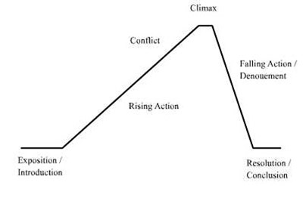

1. exposition – beginning of the story where characters and setting are introduced; establishes the conflict
2. rising action – where the main character faces a series of conflicts
3. climax – the most exciting part of the story; turning point in the story
4. falling action – events leading to the end of the story
5. resolution – end of the story; all loose ends are tied up

**Personal Narrative/Memoir**

1. memoir – an account of one’s personal life and experiences written by the person; usually focuses on a particular time or place in the author’s life
2. Memoirs are told from what point of view? First person POV
3. Who is the memoirist? The author of the memoir
4. Should a memoir be basically true? YES/NO
5. fact - can be checked or researched and proven
6. opinion – what someone thinks or feels; it cannot be proven
7. commonplace assertion – a claim that a person makes but cannot always prove

**Expository Writing**

1. What does expository mean? To inform or explain
2. What makes a thesis statement? (3 things) Your opinion, restating the prompt, your reasons why
3. How will the expository prompt look? (3 things) Read, Think, Write

**Drama**

1. Drama – story enacted onstage for a live audience
2. Comedy – drama that has a happy ending
3. tragedy – drama in which events lead to the downfall of the main character
4. playwright – author of a play

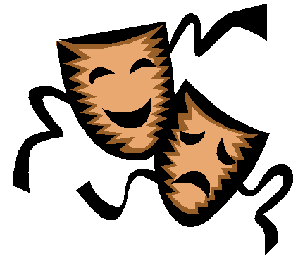

1. actors – people who perform
2. acts – the units of action
3. scenes – parts of the acts
4. dialogue – conversation between or among characters
5. monologue – long speech by one single character
6. soliloquy – speech by a character alone onstage to himself
7. asides – remarks made to the audience or to one character
8. stage directions – describes scenery and how characters speak
9. set – construction on the stage that shows time and place
10. props – small movable items the actors use

***[[THE FOLLOWING ANSWERS ARE FOR ADVANCED ONLY.]]***

***A Christmas Carol***

*Describe each person from the story and answer each question.*

1. Ebenezer Scrooge – grouchy old man who changes his ways
2. Fred – Scrooge’s nephew
3. Bob Cratchit – Scrooge’s clerk
4. Jacob Marley – ghost that wore chains forged in life
5. Mr. Fezziwig – Scrooge apprenticed under him; made people happy
6. Dick Wilkins – Scrooge’s friend who worked with him
7. Belle – Scrooge’s fiancee
8. Ghost of Christmas Past - the first of the three spirits to visit Scrooge. Shows Scrooge scenes from his past that explain how Scrooge became so bitter.
9. Ghost of Christmas Present – the second of the three spirits to visit Scrooge. Takes Scrooge around the city to see scenes of festivity and also deprivation.
10. Ghost of Christmas Yet to Come – the third of the three spirits to visit Scrooge; prompts Scrooge to adopt a more caring attitude in life and also to avoid the fate of Marley.
11. Describe Scrooge at the beginning of the play. Mean and hateful – not generous
12. Why does Marley visit Scrooge? To offer him a chance to change his life
13. Where does the Ghost of Christmas Past take Scrooge? His boarding school
14. What does the Ghost of Christmas Present show Scrooge? His nephew’s party and the Cratchit’s Christmas dinner
15. How does this affect him? He wants to stay and enjoy the festivities
16. What does the Ghost of Christmas Yet to Come show Scrooge? His own grave
17. Describe the transformation in Scrooge. Scrooge has a change of heart. A series of visits by ghosts convinces Scrooge that he doesn’t want to continue living the life he is living. He wants to mend his ways before his own death. He feels remorse, sorrow and shame.